FULL STACK PROJECT REPORT
LIBRARY CATALOG

submitted by
V.Vishnu vardhan(AP24110011112)
K.Madhan(AP24110011097)
G.Sanjana(AP24110011045)
P.Saniya(AP24110011095)



Department of Computer Science & Engineering
SRM University-AP
Neerukonda, Mangalgiri, Guntur
Andhra Pradesh - 522 240
APRIL-2026

LIBRARY BOOK CATALOG
INTRODUCTION:
The Library Book Catalog System is a web-based application developed using the MERN stack (MongoDB, Express.js, React.js, and Node.js) to digitize and simplify library operations. Traditional library systems often rely on manual processes for searching, issuing, and returning books, which can be time-consuming, inefficient, and prone to errors. This project aims to overcome these challenges by providing a centralized and user-friendly digital platform.
The system allows users to search and browse books based on title, author, or category, view detailed information, and borrow or return books online. It also provides a personalized dashboard where users can track their borrowed books and due dates. On the other hand, administrators can efficiently manage the library by adding, updating, or deleting books and monitoring borrowing activities.
This project demonstrates key concepts of full-stack development such as CRUD operations, RESTful APIs, authentication, database management, and responsive user interface design. By implementing this system, library management becomes more efficient, organized, and accessible, improving the overall user experience.
SCENARIO Based Case Study:
Scenario-Based Case Study
Meet Rahul – A College Student
Rahul is a college student who regularly visits the library to borrow books for his studies. In the traditional system, he often faces difficulties such as searching for books manually, waiting for assistance from staff, and keeping track of due dates on paper. This process is time-consuming and sometimes leads to missed deadlines or confusion.
One day, Rahul starts using the Library Book Catalog System, a web-based platform designed to simplify library operations. He registers on the system and logs in securely.
Searching and Borrowing Books
Rahul uses the search feature to find books by title or author. The system quickly displays available books along with their details. After selecting a book, he clicks on the Borrow option. The system automatically records the borrow date and calculates the due date.
Tracking and Returning Books
Rahul can view all his borrowed books in his dashboard, where due dates are clearly displayed. This helps him manage his time effectively and avoid late returns. Once he finishes reading, he returns the book through the system, and the availability is updated instantly.
Admin Perspective
Meanwhile, the admin manages the system by adding new books, updating existing records, and removing outdated books. The admin also monitors all borrowing activities, ensuring smooth operation of the library.
With the Library Book Catalog System, Rahul no longer faces the challenges of manual processes. The system saves time, improves efficiency, and provides a seamless digital experience for both users and administrators.
SYSTEM REQUIREMENTS:
1)Software Requirements:
These are the essential tools and platforms required to develop, test, and run the Library Book Catalog System efficiently:
- Operating System: Windows 10/11, macOS, or Linux — Supports cross-platform development and testing.
- Node.js (v16 or above): Provides the runtime environment for executing server-side code and handling API requests.
- npm (v8 or above): Package manager used to install and manage dependencies for both frontend and backend.
- React.js: JavaScript library used to build dynamic and responsive user interfaces for the library system.
- Browser: Google Chrome / Mozilla Firefox (latest version) — Used for rendering and testing the application interface.
- Express.js: Lightweight backend framework used to build RESTful APIs for managing books, users, and borrowing operations.
- MongoDB: NoSQL database used to store data such as users, books, and borrow records in a structured format.
- Postman: Tool used for testing API endpoints during development.
- Visual Studio Code: Code editor used for writing, debugging, and managing the project efficiently.
2. Hardware Requirements
These are the minimum and recommended system specifications for smooth development and usage:
- Processor: Intel Core i5 (8th Gen or above) / AMD Ryzen 5 or higher — Ensures efficient performance during development.
- RAM: Minimum 8 GB (16 GB recommended) — Required for running development servers, browser, and editor simultaneously.
- Storage: At least 1 GB free space — Needed for installing dependencies, database, and project files.
- Display: 1366 × 768 resolution or higher — Recommended for better coding and user interface experience.
These requirements ensure that the Library Book Catalog System runs smoothly and supports efficient development, testing, and deployment.
PROJECT ARCHITECTURE:
TECHNICAL ARCHITECTURE:
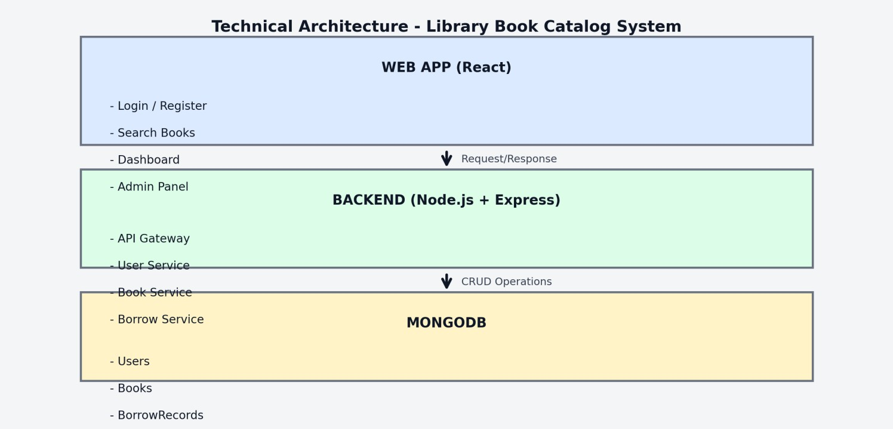

In this architecture, the flow begins with a user (represented by the “User” node) interacting with the Library Book Catalog Frontend (React application). The user searches for books, views details, and performs actions such as borrowing or returning books through the interface.
The frontend then sends a request to the Backend Server (Node.js + Express). The backend receives the request and processes it based on the required operation, such as fetching book data, handling user authentication, or managing borrow/return activities.
The backend communicates with the Database (MongoDB) to store and retrieve data. The database maintains all records including users, books, and borrowing transactions. It ensures data is stored securely and efficiently.
Additionally, the backend may use a file storage system (optional) to store book images or related documents, if such features are implemented.
Once the backend completes processing, it sends a response back to the frontend. The frontend then updates the user interface by displaying the requested information, such as book details, availability status, or user dashboard data.
The “style” settings in the architecture diagram can be used to customize the appearance of nodes. For example, the User and Database nodes can be visually highlighted for better understanding.
ER DIAGRAM:
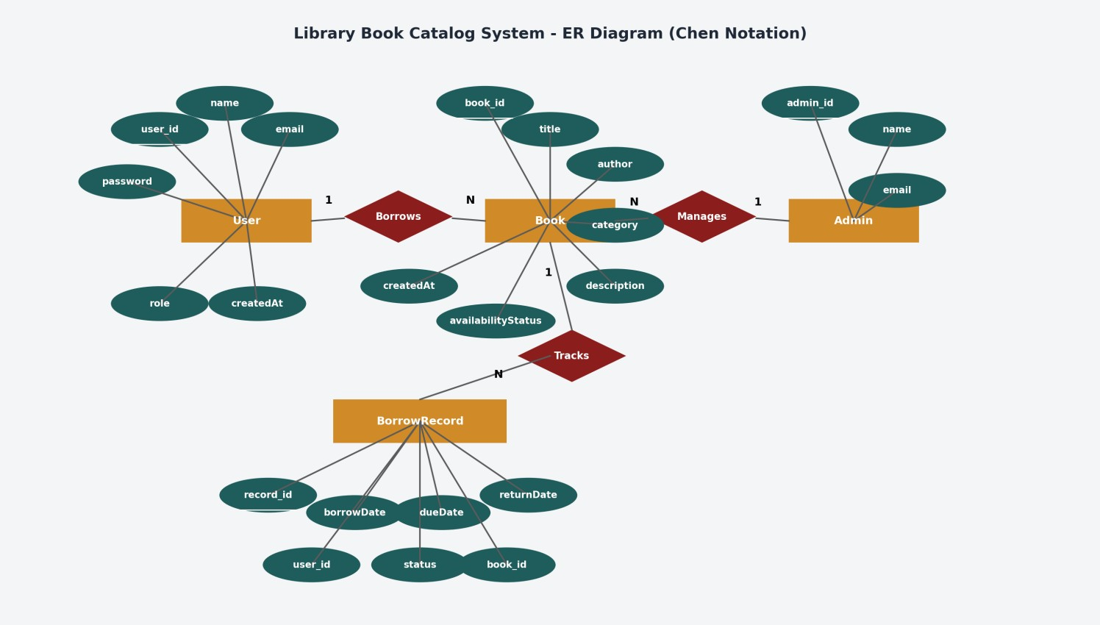

The Entity-Relationship (ER) diagram for the Library Book Catalog System represents the various entities and their relationships within the system. It shows how data is organized and how different components interact with each other.

1. Entities
- User (Student): Represents registered users of the system who can search and borrow books.
Attributes: userId, name, email, password
- Admin: Represents administrators who manage the system and book inventory.
Attributes: adminId, name, email, password
- Book: Represents books available in the library.
Attributes: bookId, title, author, category, description, availabilityStatus
- BorrowRecord: Represents borrowing transactions of books.
Attributes: recordId, userId, bookId, borrowDate, dueDate, returnDate, status

2. Relationships
- User – BorrowRecord: A user can borrow multiple books (1:N relationship).
- Book – BorrowRecord: A book can have multiple borrow records over time (1:N relationship).
- Admin – Book: Admin manages books by adding, updating, and deleting them (1:N relationship).
- Borrow Process: Connects User and Book through BorrowRecord to track transactions.

3. Attributes
Each entity contains attributes that define its properties. For example, the Book entity includes attributes such as title, author, category, and availability status.

4. Primary Keys
Each entity has a primary key that uniquely identifies each record:
- User → userId
- Admin → adminId
- Book → bookId
- BorrowRecord → recordId

5. Foreign Keys
Foreign keys are used to establish relationships between entities:
- BorrowRecord contains userId (links to User)
- BorrowRecord contains bookId (links to Book)
Overall
The ER diagram provides a clear representation of the database structure, showing how users, books, and borrowing records are connected and how data flows within the system

1. Key Features
The Library Book Catalog System includes the following key features:
- User Registration and Login:
Allows users to create accounts and securely log in to the system.
- Book Search and Browsing:
Users can search books by title, author, or category and view detailed information.
- Borrow and Return System:
Enables users to borrow books online and return them, with automatic due date tracking.
- User Dashboard:
Displays borrowed books, due dates, and return status for each user.
- Admin Panel:
Allows administrators to add, update, delete books, and monitor borrowing activity.

ROLES AND RESPONSIBILITIES:
User (Student/Reader):
- Registration and Account Management:
Users are responsible for creating an account, providing accurate details, and managing their profile information, including password security.
- Book Search and Browsing:
Users can search for books by title, author, or category. They are responsible for selecting books and viewing their details.
- Borrow and Return Books:
Users can borrow available books and must return them before the due date. They are responsible for tracking their borrowed books and return status.
- Dashboard Management:
Users can view their borrowed books, due dates, and history through their personal dashboard.
- Communication and Support:
Users may contact the admin or system support for issues related to borrowing, returning, or account management.

Admin:
- System Management:
The admin is responsible for managing the overall system, ensuring smooth performance, data security, and proper functioning of the application.
- User Management:
The admin manages user accounts, including registration monitoring, verification, and handling any issues related to users.
- Book Management:
The admin can add new books, update existing book details, and remove books from the catalog.
- Borrow Record Monitoring:
The admin tracks all borrowing activities, including issued books, due dates, and returned books.
- Data Management:
The admin ensures that all data related to books and users is accurate and up to date.

User Flow:
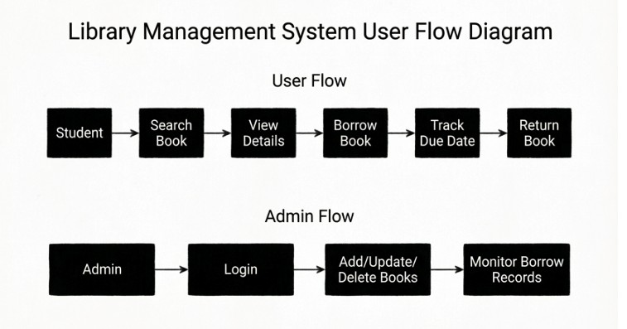

User Flow and Admin Flow
User Flow
The user flow describes how a user interacts with the Library Book Catalog System to search, borrow, and return books.
- Search Book:
The user searches for books using filters such as title, author, or category.
- View Details:
The system displays detailed information about the selected book, including availability status.
- Borrow Book:
If the book is available, the user selects the borrow option. The system records the borrow date and generates a due date.
- Track Due Date:
The user can view borrowed books and their due dates in the dashboard to manage returns efficiently.
- Return Book:
After reading, the user returns the book, and the system updates the book’s availability status.
Admin Flow
The admin flow describes how the administrator manages the system and monitors activities.
- Login:
The admin logs into the system using secure credentials.
- Add/Update/Delete Books:
The admin can add new books, update existing book details, or remove books from the catalog.
- Monitor Borrow Records:
The admin tracks all borrowing activities, including issued books, due dates, and returned books, ensuring proper system management.
The user flow focuses on book searching, borrowing, and returning, while the admin flow ensures proper management of books and monitoring of library activities.
MVC PATTERN:

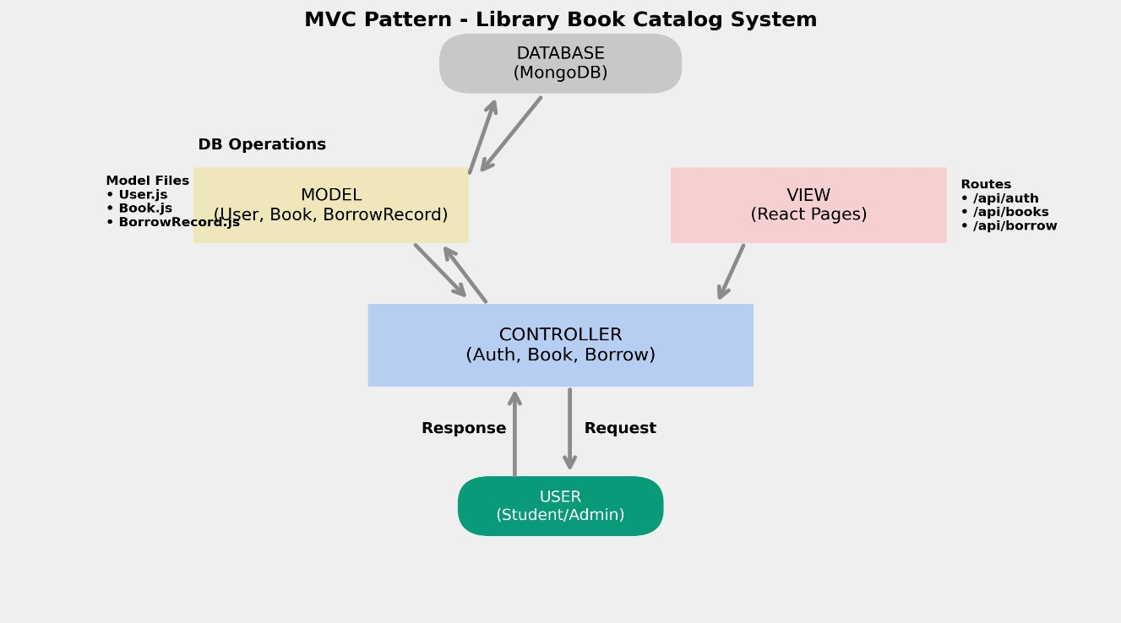
MVC Pattern
The Library Book Catalog System follows the Model-View-Controller (MVC) architectural pattern, a software design approach that separates the application into three interconnected layers. This separation improves modularity, maintainability, and scalability of the system.
Model Layer (Data Layer)
The Model layer is responsible for handling all data-related logic in the system. It defines data schemas and performs database operations such as create, read, update, and delete (CRUD).
In this project, models are implemented using Mongoose, which provides a schema-based solution to interact with the MongoDB database. The main models include:
- User Model → Stores user details such as name, email, and password
- Book Model → Stores book information like title, author, category, and availability status
- BorrowRecord Model → Stores borrowing transactions including borrow date, due date, return date, and status

Controller Layer
The Controller layer acts as an intermediary between the View (routes/frontend) and the Model. It handles incoming requests, processes input data, applies business logic, and interacts with the Model to perform required operations.
In this project, controllers are responsible for:
- Handling user registration and login
- Managing book operations (add, update, delete, fetch books)
- Processing borrowing and returning of books
- Tracking due dates and updating book availability
After processing, the controller sends an appropriate response back to the client.
View Layer (Routing Layer / Frontend)
The View layer represents the user interface and interaction part of the application. In this project, it is implemented using React.js (frontend) and routing in the backend.
It includes:
- Login and registration pages
- Book search and listing interface
- Book details page
- User dashboard (borrowed books and due dates)
- Admin panel for managing books
The View sends HTTP requests (GET, POST, PUT, DELETE) to the backend and displays the responses received from the control

Advantages of Using MVC in This Project
- Separation of Concerns: Each layer has a clearly defined responsibility, improving readability and maintainability.
- Scalability: New features can be added easily by creating new models, controllers, and routes.
- Reusability: Business logic can be reused across different parts of the application.
- Testing: Each layer can be tested independently, improving system reliability.
- Collaboration-Friendly: Multiple developers can work on frontend, backend, and database simultaneously without conflict.

Project Setup And Configuration. :
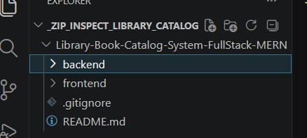
Creating Project Folder
- Create a new folder with your project name (e.g., Library-Book-Catalog-System).
- Inside that folder, create two subfolders.
- Name one folder as Client (for frontend).
- Name another folder as Server (for backend).
- Open the main project folder in Visual Studio Code.
Client Setup (Installing React App)
- Open the Client folder in the VS Code terminal.
- Create a React application using Vite: ● npm create vite@latest . -- --template react ● Select the following options: o Framework: React o Variant: JavaScript
- Install all required dependencies:
- npm install
- Start the React development server:
- npm run dev
Server Setup (Node.js + Express)
- Open the Server folder in the VS Code terminal.
- Initialize the Node.js project:
- npm init -y
- Create the main file:
  - server.js
- Create the following folders:
  - models → Contains schemas for User, Book, BorrowRecord o controllers → Contains business logic (user, book, borrow operations) o routes → Defines API endpoints
The project is divided into Client (React frontend) and Server (Node.js backend), ensuring a clean and scalable full-stack architecture for the Library Book Catalog System.

BACKEND DEVELOPMENT:
Backend Structure:.
BACKEND DEMO VIDEO:
https://drive.google.com/file/d/1ELl2weUubhFsItBEDAMHuleBPu5aPlJG/view?usp=s
haring
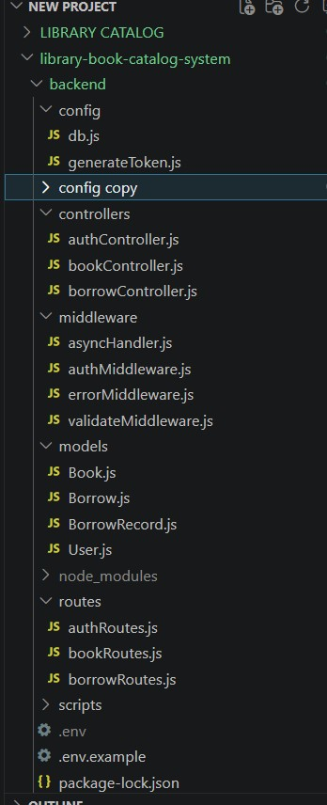
Controllers
- authController.js -> Handles user registration and login. - bookController.js -> Handles book listing, details, search, and admin CRUD operations.
- borrowController.js -> Handles borrow and return logic, due date, and borrow history.
Config
- db.js -> Database connection setup using MongoDB and Mongoose.
- generateToken.js -> JWT token creation utility.
Middleware
- authMiddleware.js -> JWT authentication and role-based authorization.
- validateMiddleware.js -> Input validation error handling for request payloads.
- errorMiddleware.js -> Centralized not-found and error response handling.
- asyncHandler.js -> Wrapper to catch async controller errors.
Models
- User.js -> Schema/model for user accounts.
- Book.js -> Schema/model for books in the catalog.
- BorrowRecord.js -> Schema/model for borrowed/returned transaction records.
Routes
- authRoutes.js -> Routes for register and login APIs.
- bookRoutes.js -> Routes for public book APIs and admin-only book management APIs.
- borrowRoutes.js -> Routes for borrow, return, user borrow list, and admin record list.
Other
- server.js -> Entry point that configures middleware and mounts API routes.
- scripts/seedData.js -> Inserts sample admin/user accounts and sample books. DATABASE DEVELOPMENT:
1. Configure MongoDB
- Install Mongoose:
In your Node.js project directory, run: npm install mongoose
- Create Database Connection:
Establish a connection between the backend and MongoDB using Mongoose.
- Create Schemas & Models:
Define schemas based on the ER diagram for:
o User o Book o BorrowRecord Create Database Connection
Ensure the database is connected before performing any backend operations. The connection code is implemented in a configuration file (e.g., config.js) as shown below
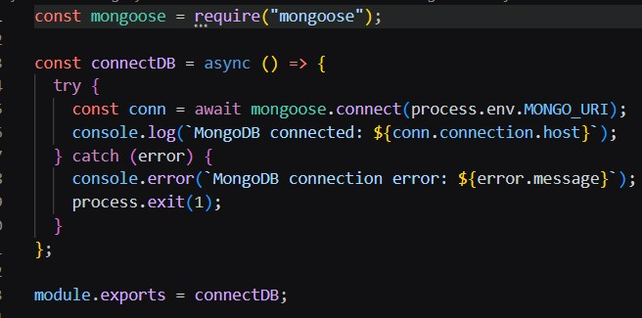
Create Schemas:
Firstly, schemas are defined using Mongoose to structure the data in the MongoDB database. The schema design is based on the ER diagram, ensuring proper relationships between entities.
In this system, schemas are created for:
- User → Stores user details such as name, email, and password
- Book → Stores book information like title, author, category, and availability status
- BorrowRecord → Stores borrowing details including borrow date, due date, return date, and status
These schemas help maintain data consistency, relationships, and efficient CRUD operations in the application.
1)Users.js → Schema/model for user accounts
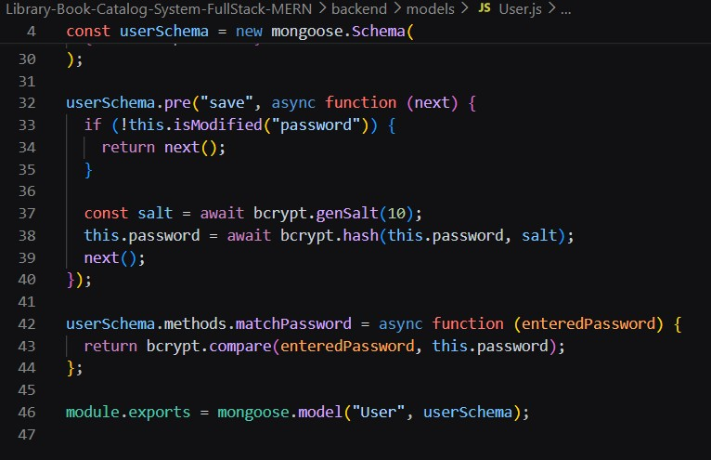

- Book.js → Schema/model for books added and managed by admin
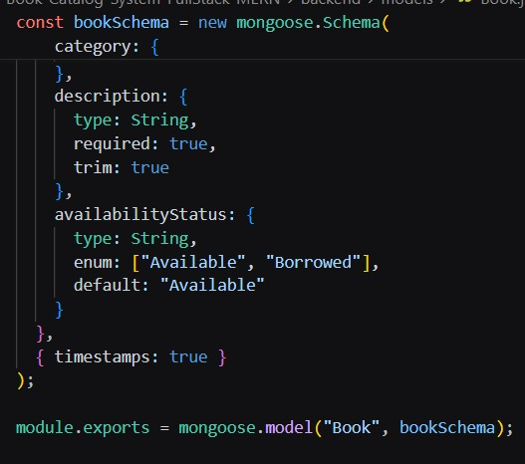

3)BorrowRecord.js → Schema/model for user borrowed book records.
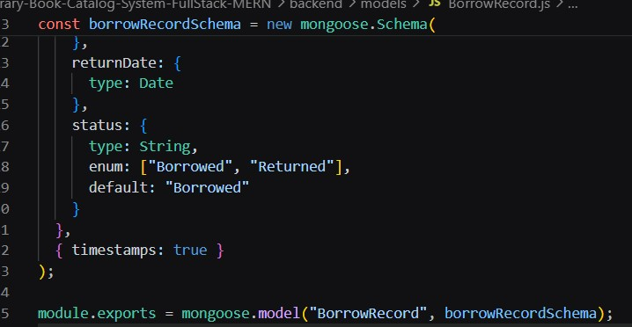

FRONT-END DEVELOPMENT:
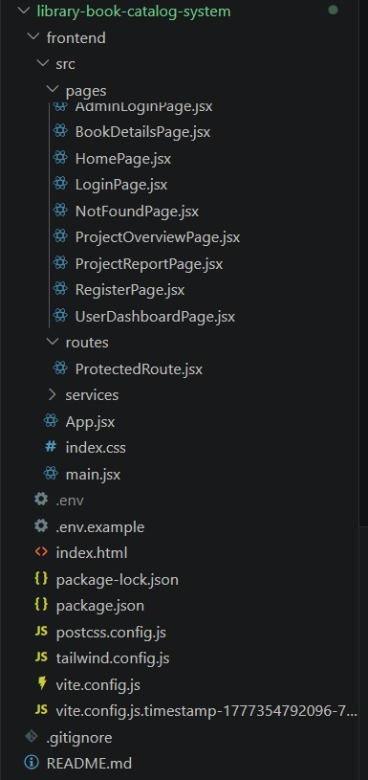
Frontend Structure:
Pages (src/pages)
- LoginPage.jsx -> User login page.
- RegisterPage.jsx -> User registration page.
- HomePage.jsx -> Book catalog page with search/filter and borrow actions.
- BookDetailsPage.jsx -> Detailed book view with borrow action.
- UserDashboardPage.jsx -> User borrowed books, due dates, and return actions. - AdminDashboardPage.jsx -> Admin dashboard to add/update/delete books and monitor borrow records.
- NotFoundPage.jsx -> Fallback page for invalid routes.
Components (src/components)
- Navbar.jsx -> Shared top navigation for user/admin based on role.
- BookCard.jsx -> Reusable book card component in listings.
- SearchBar.jsx -> Reusable search input component.
- ProtectedRoute.jsx -> Route guard for authenticated and role-based access.
Context / Services / Routes
- context/AuthContext.jsx -> Global authentication state and login/logout handlers.
- services/api.js -> Axios service methods for auth, books, borrow/return APIs.
- routes/ProtectedRoute.jsx -> Route export helper.
App Entry
- App.jsx -> Main route mapping.
- main.jsx -> React entry point.
- index.css -> Global styles and theme tokens.
FRONTEND DEVELOPMENT VIDEO:
https://drive.google.com/file/d/1BtM6anNQw6oEw2ni4cwIcVjNIoIXKvJ7/vie w?usp=sharing OUTPUT SCREENSHOTS:
USERLOGIN PAGE:
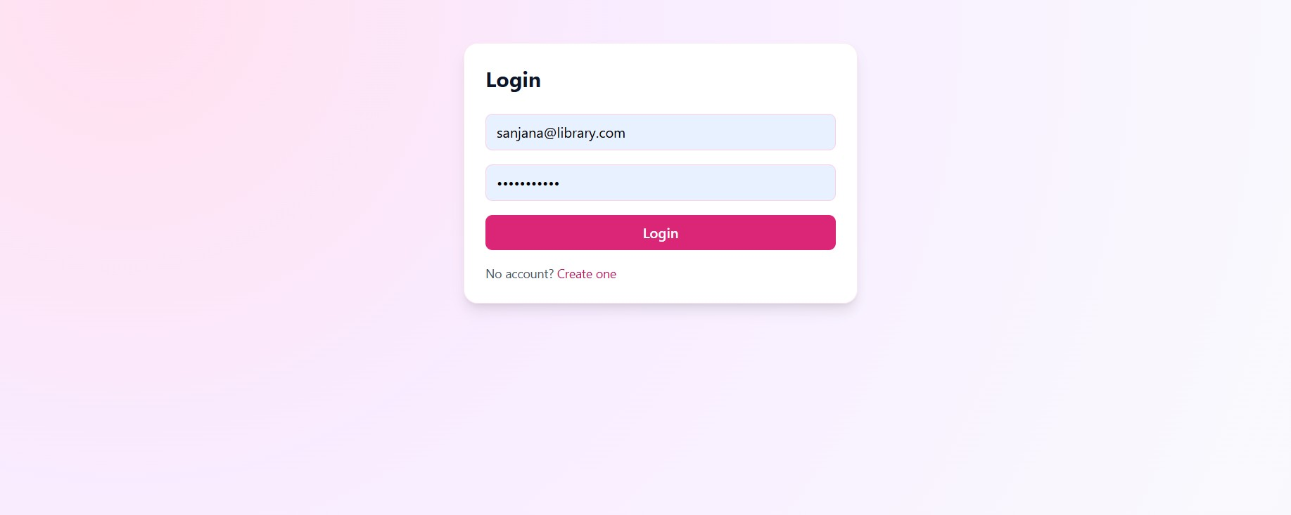
ADMIN LOGIN PAGE:
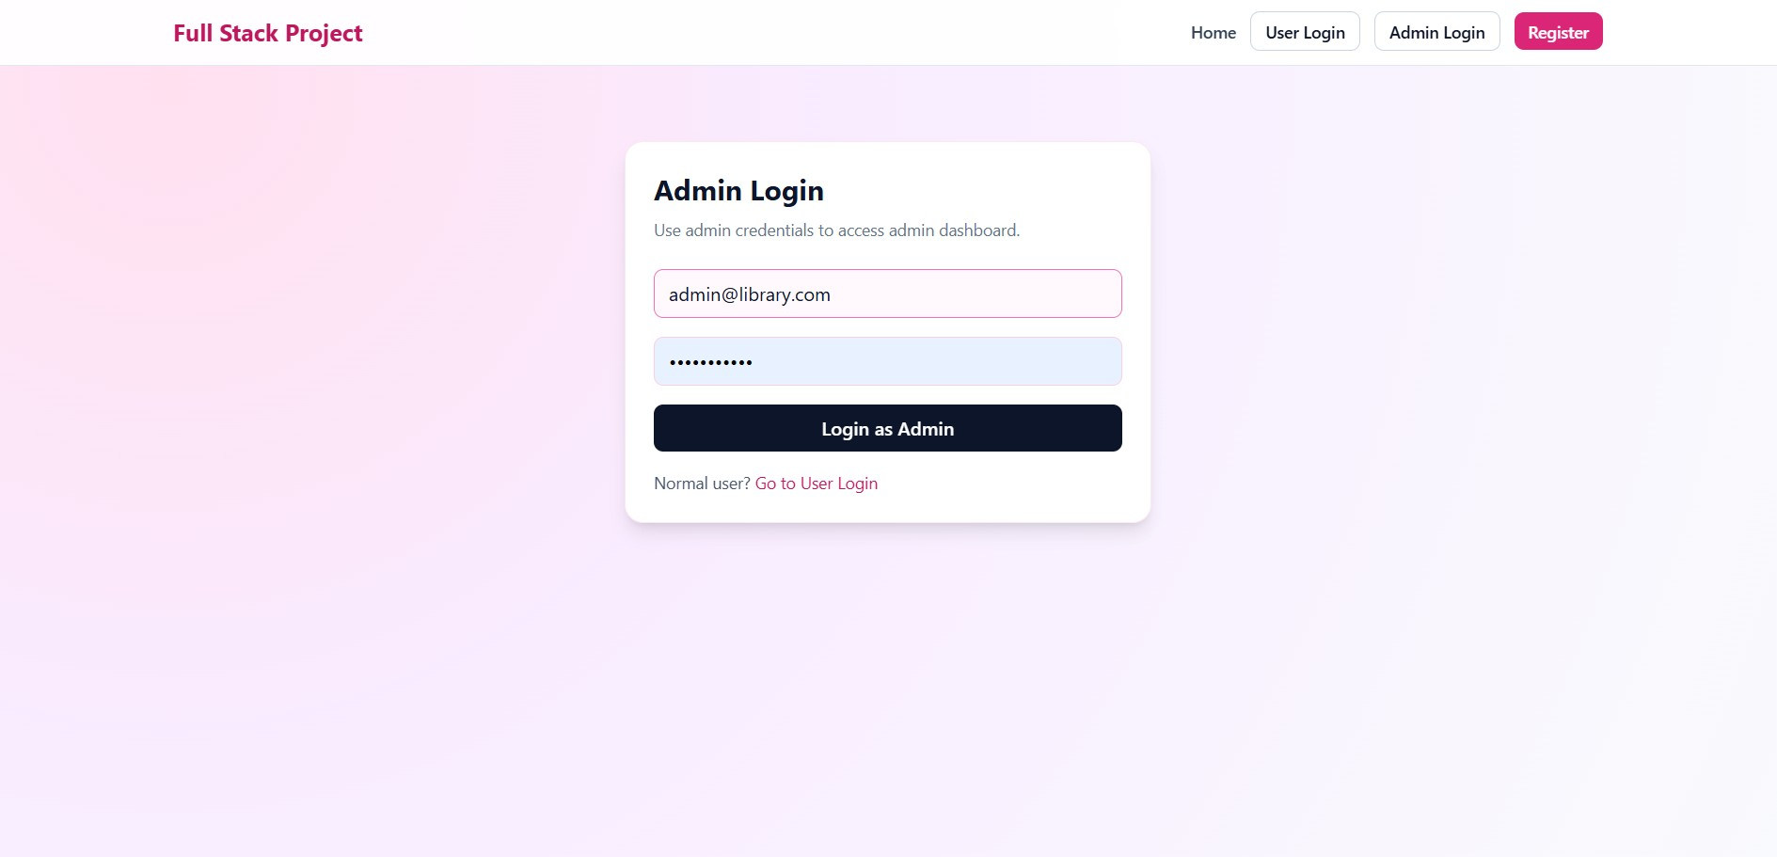

BOOK DETAILS PAGE:
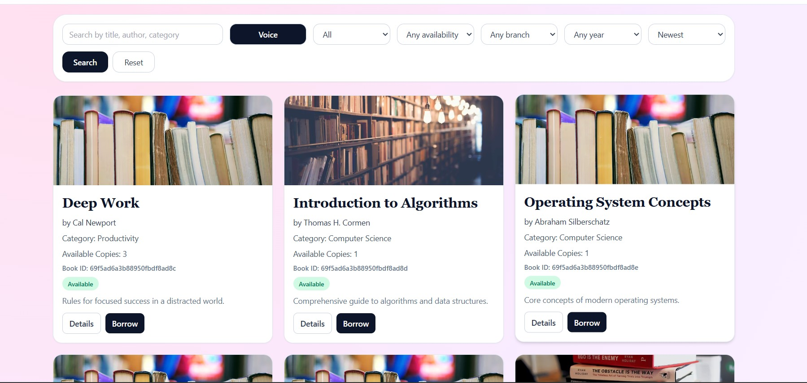

BOOK SEARCH PAGE:
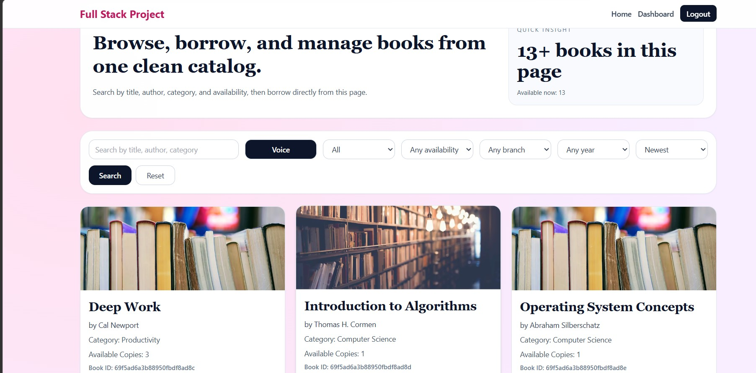

USERDASHBOARD:
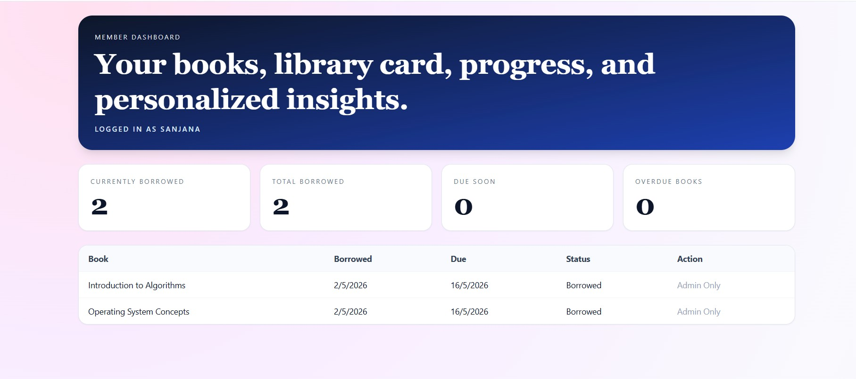

ADMIN DASHBOARD
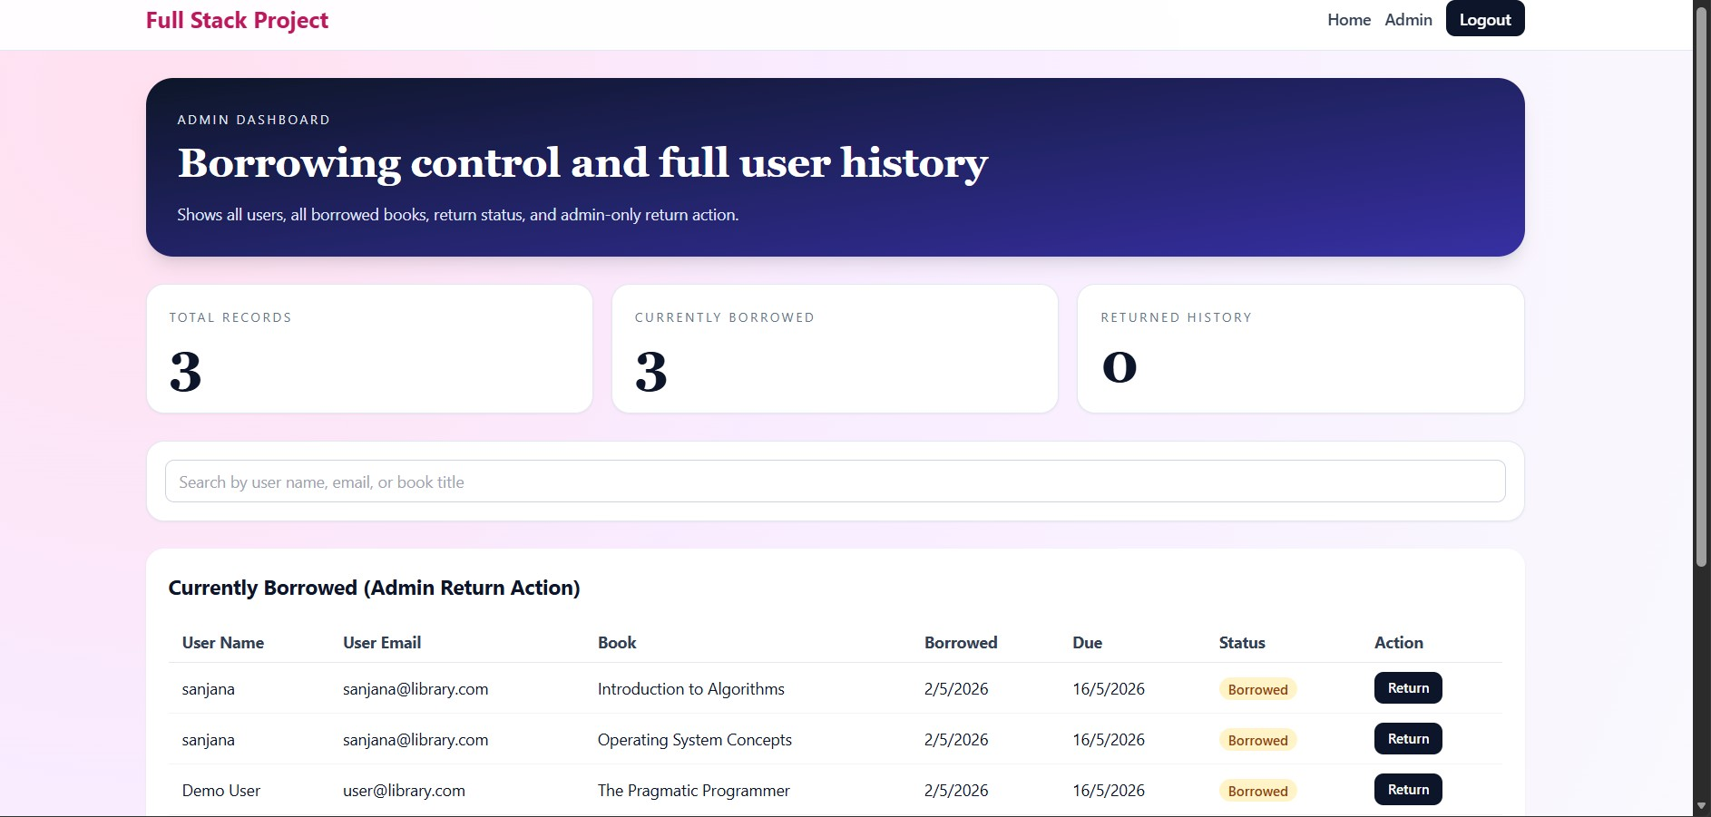
Demo Video Link:
https://drive.google.com/file/d/1rqfxXRC2e1MGAwTeL4DD8mn_QvHRLY5b/vi ew?usp=sharing

Code Drive Link:
https://drive.google.com/drive/folders/1m5DC_CPTDAx1_VomugEL7BmZz80Y
BrGT?usp=drive_link
GITHUB LINK: https://github.com/AP24110011095/fullstack-project-library-catalog

